**Vi Editor - Assignments**

1. Invoke the vi editor with a filename (which is to be created) : vi filename

2. Type a few lines(at least 10) in the editor. Let one or more lines contain the words given below.

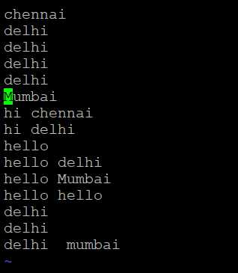

delhi mumbai chennai Mumbai

3. Save the file without exiting the editor : esc :w

4. Navigate quickly to the beginning & end of the file : in esc mode beginning of the line ‘gg’ and end of the line ‘G’

5. Delete first two lines & copy it after the last line. : 2dd and p

6. Now Copy the last two lines & paste them before the first line. : esc gg 2dd and paste

7. Combine last two lines of the file in a single line. : esc mode type command as : (give the number to attach the line) 10 join

8. How will you insert a line before the first line? (Hint : Find such an option in the tutorial document) : insert enter

9. How will you paste a yanked buffer before the current line? : yy(is used to copy the data) p(paste the data)

10. Search the document for a string “delhi” : /delhi

11. Replace a single occurrence of “delhi” with “Mumbai” : s/delhi/Mumbai\c to remove case sensitive

12. Replace all occurrences of “delhi” on a particular line with “Mumbai” using one command : s/delhi/Mumbai/g (g—used to replace)

13. Replace “delhi” with “mumbai” for the entire document using one command. :1,$/delhi/Mumbai/g

14. Replace all occurrences of “delhi” with “mumbai” for part of a document (e.g. line number 13 to 37). : n,ms/delhi/Mumbai

15. Undo the above command : u

16. Replace only the first occurrence of “delhi” with “mumbai” in each line, for part of a document (e.g. line number 13 to 37). : 1,$s/delhi/mumbai

17. Undo the above comment. Redo it. Undo it again. : ^r

18. Replace all occurrences of “delhi” with “mumbai” for complete file interactively. : %s/delhi/Mumbai/gc

19. Search for a word backwards. Loop through all matches. For backward : ?delhi for loop 🡪n

20. Search for a word forwards. Loop through all matches : /mumbai

21. Join two lines together. : join (give the line which we want to join)

22. Enable line numbering and then disable it : esc mode : set number/set nonumber

23. Make the search case insensitive : /delhi\c

24. Delete 4 lines (and then paste them somewhere else) : 4dd and p

25. What is the command to delete part of the line starting from the current cursor position? : d$

26. What is the command to delete the current word? : dw

